

**BAHRIA UNIVERSITY**

DEPARTMENT OF SOFTWARE ENGINEERING

**BSE-5B**

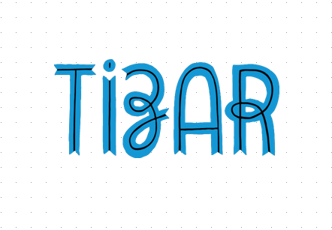

FORM BUILDER WEB APPLICATION

COURSE NAME: **WEB ENGINEERING LAB**

COURSE CODE: **SEN – 310**

GROUP MEMBERS: **Khizar Hayat & Tamkeen Ahmed**

**INTRODUCTION**

Tizar allows you to quickly build well-designed, mobile-friendly and accessible web forms with validation and semantics like e-mail fields in place by simply using "drag-and-drop" and add them to a page.

Whether you’re looking to generate leads, collect order payments, conduct customer surveys, find applicants for a job, or register guests for an event, Tizar’s easy-to-use form builder lets you build a customized online form to fit your exact needs in minutes. It lets you to download and print the form right after creation.

**PROBLEM STATEMENT**

“It was merely a hustle to create forms offline by using Word Processing, due to complexity while creating lengthy forms and to make the valid selection for consistent pattern of questions and answers. Hence, the procedure took plenty of our time and cost.”

**SOLUTION**

In order to fix the issues, we came up with an idea to design a Web based Solution *“Tizar”* that contains all the key features you might be looking for in a Form Builder application. It is easy to use, efficient and responsive. It lets you make quick and smart selection for the type of forms you aim to create. Use our drag & drop form builder to easily create your own online form or survey. Choose from over various customizable templates and question types to create registrations, customer surveys, order forms, lead forms and more.

Share a secure link to your form or embed it into a page on your site. Your forms are automatically responsive for all device types: desktops, tablets, and phones. We handle hosting your form and processing your results.

**TECHNOLOGY**



**HTML JAVASCRIPT BOOTSTRAP**

** **

**ANGULAR JS BOOTSTRAP**

**SNAPSHOTS**

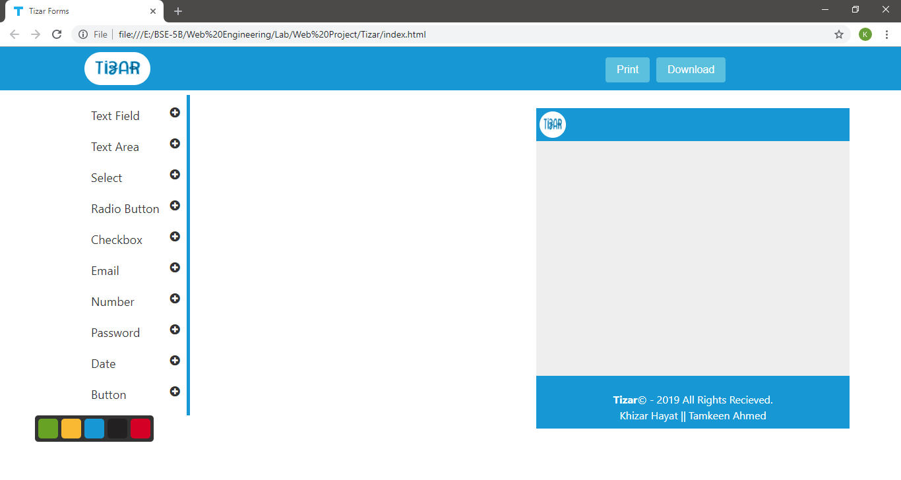

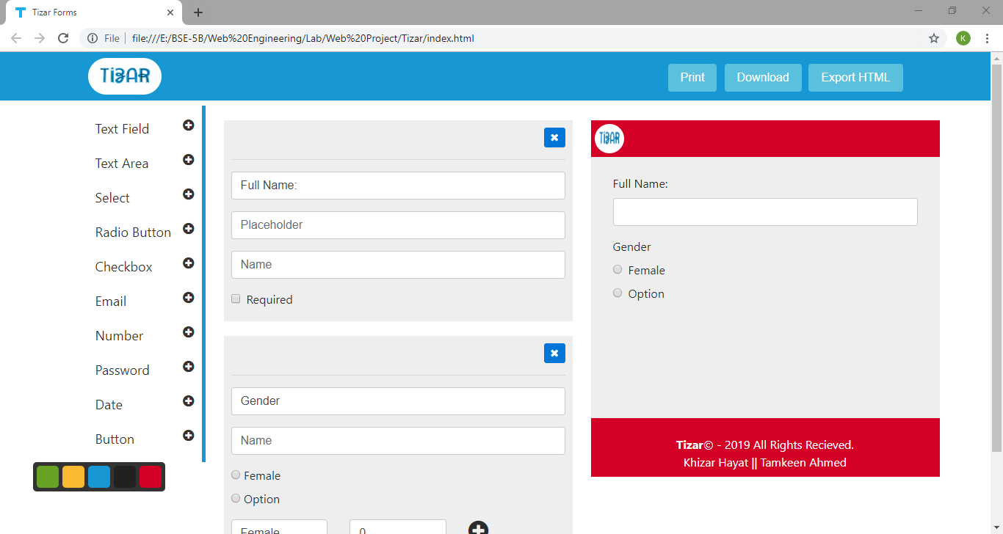

**CONCLUSION**

The technology we used for implementing the modules and directives in our application is AngularJS, with its attractive animations. To structure the layout of website, HTML and Bootstrap is implemented for responsiveness while JS and JQuery gives us the proper functionality with efficient results.

Combination of all these technologies lead to Tizar, a platform where one can easily design and customize validating and survey forms by just simply using drag and drop feature. It is designed to provide maximum ease to the users, given the resources and time Tizar will provide with what it is asked for.

**REFERENCES**



**1: W3Schools**



**2: StackOverflow**



**3: CodePen**



**4: GitHub**